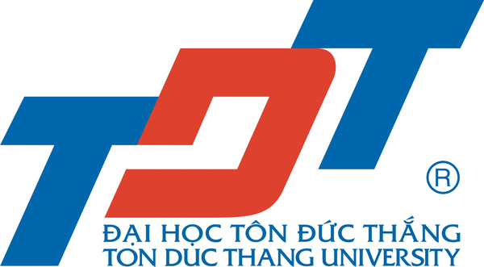**Ton Duc Thang University**

19 Nguyen Huu Tho street, District 7, Ho Chi Minh City, Vietnam

**Course (Online): Sustainability towards Environment and Food Production**

**(2022 Syllabus)**

**Faculty of Applied Sciences**

|  |  |  |  |  |
| --- | --- | --- | --- | --- |
| **Date** | **Time (GMT+7)** | **Topic** | **Course outline** | **Course Instructor** |
| Feb. 22 (Tuesday) | 18:00-18:15 | - Opening ceremony - Course design and evaluation |  | All lecturers |
| Feb. 22 (Tuesday) | 18:15-21:00 | Biomass and Residues: Renewable sources for Bioenergy and Biomaterials | 1. Chemistry of Plant Biomass and Residues 2. Production of Biofuel Towards Sustainable Development 3. Technological Production of Biomaterials and Their Applications 4. Merging Green Chemistry and Bio-refinery | Dr. Vo Nguyen Xuan Phuong |
| Feb. 25 (Friday) | 18:00-21:00 | Biodegradation and bioremediation of herbicides in soil | 1. Introduction of herbicides 2. Biodegradation of herbicides 3. Procedure for isolating bacteria for biodegradation 4. Mechanism of herbicides bacterial degradation 5. Bioremediation potential of herbicides-degrading microorganisms | Dr. Nguyen Ngoc Tuan |
| Mar. 01 (Tuesday) | 18:00-21:00 | Innovation technology of the integrated rice - fish aquaculture farming for safeguard ecosystem services management | 1. Sustainable ecosystem services and environmental management  2. Technical efficiency of rice farming in the Mekong Delta, Vietnam 3. Current situation of rice, aquaculture and fisheries production 4. Integrated rice - fish farming system technology 5. Integrated rice - shrimp farming system technology 6. The evolution of the blue‑green revolution of rice ‑ fish cultivation | Dr. Chau Thi Da |
| Mar. 04 (Friday) | 18:00-21:00 | Protein engineering and its application in food industry | 1. Recombinant DNA technology 2. Host system 3. Purification system | Dr. Pham Dinh Chuong |
| Mar. 08 (Tuesday) | 18:00-21:00 | Mushroom cultivation and applications of spent substrates in biotechnology and environment | 1. Mushroom cultivation techniques (edible and medicinal mushroom);  2. Values of mushroom product (fruit body, mycelium, extract);  3. Applications of spent substrates/ materials | Ms. Nguyen Khanh Linh |
| Mar. 11 (Friday) | 18:00-20:30 | Biotechnological approaches and breeding strategies for salinity tolerance in rice | 1. Introduction 2. Approaches to improvement in salinity tolerance 3. Molecular Approaches to salinity Tolerance 4. Biochemical marker Approaches to salinity Tolerance | Dr. Pham Thi Thu Ha |
| Mar. 11 (Friday) | 20:30-21:00 | Comments and closing ceremony |  | All lecturers |

***Course organizer***

**Nguyen Ngoc Tuan, Ph.D.**

Assistant Dean, Faculty of Applied Sciences, TDTU, VIETNAM

***Teaching team***

|  |  |
| --- | --- |
| **Nguyen Ngoc Tuan, Ph.D.**  Assistant Dean, Faculty of Applied Sciences, TDTU, VIETNAM  Email: nguyenngoctuan@tdtu.edu.vn  https://scholar.google.com/citations?hl=en&user=Gw8vusUAAAAJ&view_op=list_works&sortby=pubdate | **Pham Thi Thu Ha, Ph.D.**  Vice Director, Genomic Research Institute and Seed, TDTU, VIETNAM  Email: phamthithuha@tdtu.edu.vn  https://scholar.google.com/citations?hl=en&user=_S87e38AAAAJ&view_op=list_works&sortby=pubdate |
| **Chau Thi Da, Ph.D.**  Faculty of Applied Sciences, TDTU, VIETNAM  Email: chauthida@tdtu.edu.vn  https://scholar.google.com/citations?user=TyiUvpUAAAAJ&hl=en | **Vo Nguyen Xuan Phuong, Ph.D.**  Faculty of Applied Sciences, TDTU, VIETNAM  Email: vonguyenxuanphuong@tdtu.edu.vn |
| **Pham Dinh Chuong, Ph.D.**  Faculty of Applied Sciences, TDTU, VIETNAM  Email: phamdinhchuong@tdtu.edu.vn  https://scholar.google.com.vn/citations?hl=en&user=rZJVkNAAAAAJ&view_op=list_works&sortby=pubdate | **Nguyen Khanh Linh, Master**  Faculty of Applied Sciences, TDTU, VIETNAM  Email: nguyenkhanhlinh@tdtu.edu.vn |